Chapter 12, Problem 38.

Given the circuit in Fig. 12.57 below, find the total complex power absorbed by the load.

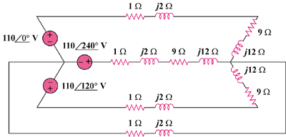

Figure 12.57
For Prob. 12.38.

